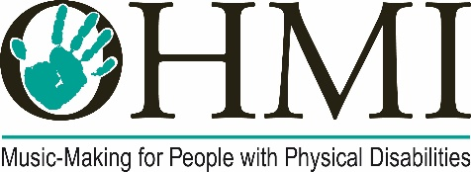

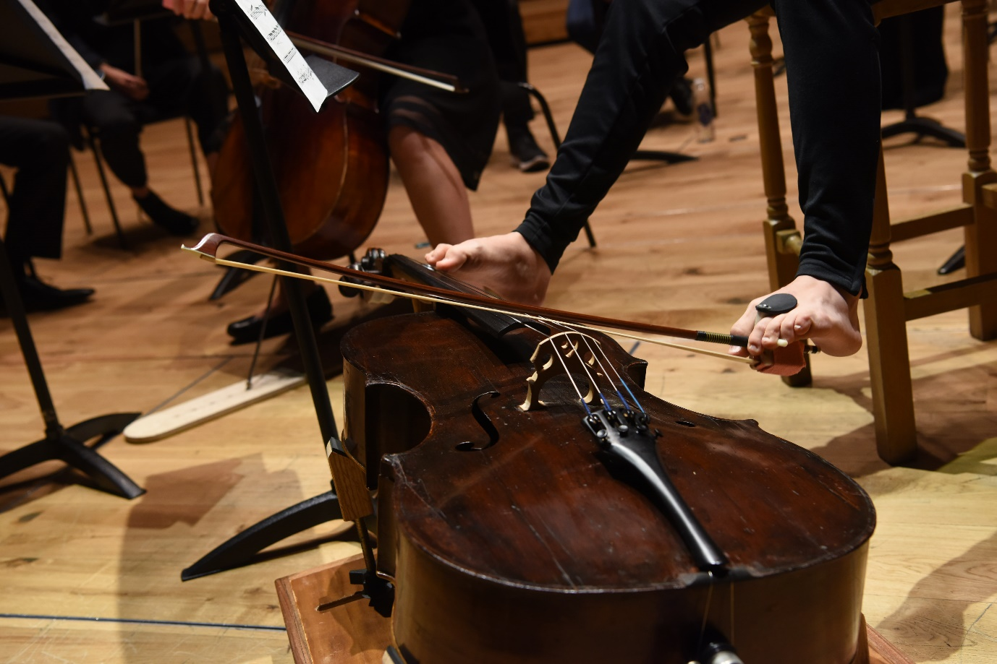

Appointment of Chair of Trustees
Briefing Pack

Introduction from the Founder and outgoing Chair of Trustees

The OHMI Trust was formed in 2011, since when it has established itself as the only charitable organisation in the world focused on the development of musical instruments for people with physical impairments.

I have taken OHMI from an idea formed in discussion over the kitchen table, to a point where our arguments and our work are now increasingly embraced by government, the disabled community and, essentially, the musical world. It is my belief, though, that after 12 years, new energy from the Chair would benefit the Trust. I am committed as ever to OHMI’s work, but I firmly believe that all organisations can stultify if not re-energised with new ideas. It is that which leads me and the OHMI Trustees to search for someone who can lead the organisation into its next phase of development.

If, after reading through the information below, you are excited by the challenges ahead, we really want and need to hear from you. Without exaggeration, the Trust’s work is life changing.

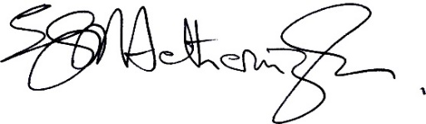
Dr Stephen Hetherington, MBE

About The OHMI Trust

The OHMI Trust works to remove the barriers to music-making faced by people with physical disabilities. Any impairment in an upper limb makes many [or most] musical instruments unplayable to any reasonable standard. As a result, thousands are excluded from music-making. The Trust strives for full, undifferentiated, participation in musical life for disabled people through the creation and provision of adapted musical instruments and enabling apparatus. Our work has been described as “extraordinary and pioneering” by Lord Nash, the Government’s lead Non-Executive Director and formerly Parliamentary Under-Secretary for Schools.

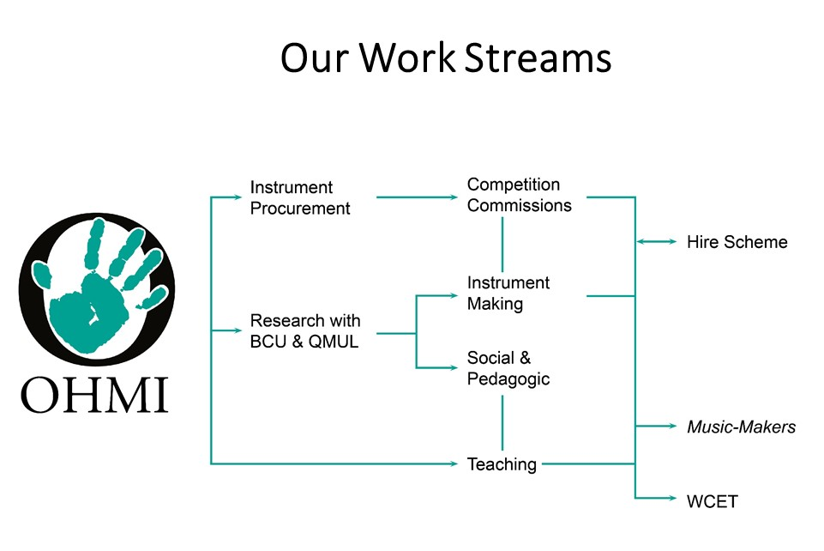
OHMI works in a wide variety of ways to achieve our objectives, and has several strands to its work.

Instruments
The biennial OHMI Competition remains our primary source of instruments. ​We also commission the development of instruments and enabling apparatus where no solution already exists or which need further refinement. Instruments borne from the OHMI Competition or from one of our commissions are available to hire from the OHMI Instrument Hire scheme. ​This valuable service enables people with physical impairments to explore the instruments and equipment before committing to a purchase.

Teaching
Our teaching programmes provide opportunities for children with limb impairments to learn a musical instrument that has all the capabilities of the traditional equivalent but also meets their physical needs. It’s known as the OHMI Music-Makers programme and it offers each participant weekly, individual 30-minute lessons from a specialist local teacher. Music-Makers began life as pilot projects in Birmingham (2015) and Surrey and Hampshire (2016) but is now extending across the UK. It has also led to our support for WCET (Whole Class Ensemble Teaching) in English primary schools, enabling the National Plan for Music Education to include physically disabled children.

Whilst aimed particularly at school children and young people, it is not age-limited.
​

Raising Awareness
The OHMI team regularly attend and to speak at meetings and conferences to raise awareness about music provision for disabled people. Over the years, we have attended events hosted by Music Education Hubs, schools, arts bodies, hospitals, occupational therapy teams, disability charities, and universities, as well as music conferences in the UK and overseas.

Research
The OHMI Research Partnership (the "ORP") was launched in 2019 as a collaboration between the OHMI Trust, Queen Mary University of London, and Birmingham City University. Its purpose is to form new research partnerships with universities, researchers, musicians, educators, sociologists and instrument makers globally. Areas of potential research include instrument design and adaptation, music education, policy issues and social impacts.

OHMI’s continued success comes from the people we work with - beneficiaries, instrument makers, researchers, staff, funders, and trustees. It is their skills, experience and energy that are the strength of the organisation. Under the leadership of the current chair of trustees, Stephen Hetherington, and with the full support of the board, OHMI has achieved a huge amount since its inception. Information on some of those achievements may be found at https://www.ohmi.org.uk/history-of-ohmi.html.

The role of the board of trustees

The Board of Trustees is responsible for the overall governance and strategic direction of the charity. It develops the Trust’s mission and objectives, ensures legal and regulatory compliance, and sets policies and strategies that carry forward our mission. Trustees oversee the management of OHMI’s finances and resources and the proper discharge of charitable funds, ensuring sound control of the charity’s affairs on behalf of all stakeholders.

The General Manager is accountable to the Board for the day-to-day running of the Trust’s work. Trustees are expected to provide practical advice and support to the staff team.

In addition to their role on the Board, all Trustees are encouraged to attend or participate in projects, fundraising activities, concerts, and events, as volunteer representatives of the Trust and in support of the General Manager and her team.

Role description

In addition to their core role as a trustee, the Chair of the Board will:

- Lead the Board of Trustees in fulfilling its governance role and compliance with charity best practice.
- Provide strategic leadership towards the fulfilment of the Trust’s objectives.
- Represent the Trust to external stakeholders, helping to promote understanding of the issues the Trust is addressing and forging links with potential funders.
- Work with the General Manager on a weekly basis, to maintain the flow of work between Board meetings.
- Chair meetings of the Board, either in person (in Birmingham) or via video-link. Meetings currently take place on Tuesday mornings on a monthly basis (with occasional additional meetings as required) and last for around two hours. Future dates will be reviewed if the current pattern does not suit the incoming chair.
- Collaborate with the General Manager, and other Trustees as required, to generate Board papers.

Person specification

Particular skills required by the Chair are:

• A strategic thinker, able to lead the Trust collaboratively and harness the talents and energies of both the trustee board and staff team and foster effective collegiate working.
• Excellent relationship-building and communication skills. Able to take-on the important ambassadorial role for the OHMI Trust and represent its work with a wide range of external stakeholders, including funders, partners and policy-makers.
• Effective programme management and delivery experience, with capacity to innovate and think creatively about operational models that can enable expansion of the Trust’s work.
• Affinity with the goals and values of the OHMI Trust, in particular, an understanding of the life-transforming value of music, the challenges of disability, and the importance of inclusion.

These skills may have been developed in a range of different settings, including from experience of living with a physical impairment and the social and economic barriers faced by disabled people.
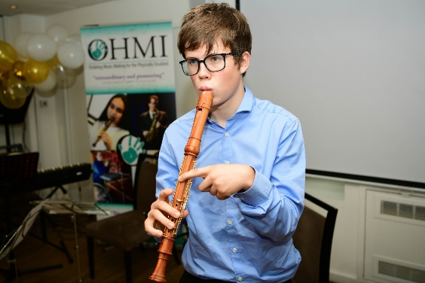

Benedict Meissner performing on a one-handed treble recorder at OHMI’s Tenth Anniversary Awards.

Inclusivity

OHMI is committed to ensuring that its leadership, governance and workforce represent the diversity within the communities we serve. We are committed to equality of opportunity and welcome applications from all suitably qualified candidates, irrespective of their personal backgrounds. We particularly welcome candidates with lived experience of disability.

Current Trustees, Patrons, Ambassador and Staff

Biographies of the current Trustees, Patrons, Ambassador and Staff can be found at https://www.ohmi.org.uk/team.html

How to apply

Please send your CV and an expression of interest outlining your suitability for the role to Rachel Wolffsohn: rachel@ohmi.org.uk.

The OHMI Trust,
29 Woodbourne Road,
Harborne,
BIRMINGHAM.
B17 8BY

We would like to receive them by 13th February 2023.

If you would like an informal conversation about the work of The OHMI Trust, please contact Rachel by email or phone (07849 726309) to make arrangements.

Further information about OHMI can be found at www.ohmi.org.uk and in the most recent annual report and accounts at Latest Annual Report - The OHMI Trust.

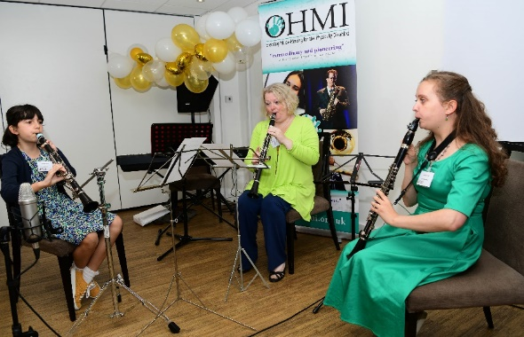
A trio of performers using one-handed clarinets and performing at OHMI’s Tenth Anniversary celebrations.

